Annex 1 to the Guidelines for the applicants of the call “Implementation of the Model of Well-being Advisers“ under the programme “Health“ of the European Economic Area financial mechanism 2014-2021

Principles of the provision of the services of Well-being Advisers

INTRODUCTION
In Lithuania, as all over the world, incidence of mental and behavioural disorders increases. According to the data from Lithuanian Institute of Hygiene, in the last 10 years (from 2007 to 2017), the incidence of these illnesses increased (from 23.3 cases per 1,000 inhabitants of the country to 35.2 cases per 1,000 inhabitants of the country). Prevalence of mental illnesses and illnesses of behavioural disorder increased from 55.6 cases per 1,000 inhabitants of the country to 78.3 cases per 1,000 inhabitants of the country. Depression is one of the most common and debilitating mental illnesses. Incidence of depression in Lithuania amounts to 4.76 per 1,000 inhabitants of the country, and prevalence – 16.3 per 1,000 inhabitants of the country. Depression is particularly associated with suicide. Despite the fact that the number of suicides in Lithuania has been decreasing in recent years (according to the data from Lithuanian Institute of Hygiene, from 2000 to 2016, in Lithuania, the suicide rate decreased from 45 cases to 31 cases per 1,000 inhabitants of the country), in suicide statistics, Lithuania still ranks first in Europe and falls in the top ten in the world. Numbers are really threatening: according to the latest data from Eurostat, in Lithuania in 2017, a standardized rate of death by suicide amounted to 31.5 cases per 100 thousand inhabitants of the country (47.2 cases per 100,000 of men and 9.1 cases per 100,000 of women). Thus, Lithuania is the absolute leader in terms of the number of suicides. In 2017, 749 people committed suicide in Lithuania (596 men and 153 women), and worldwide – 793,000 people, on average 10.5 cases per 100,000 inhabitants, in Europe – 11 cases per 100,000 inhabitants.
UK scientists (London School of Economics and Political Science), having conducted well-being studies worldwide, say that depression and anxiety are the main cause of suffering. Depression, that during their lifetime affects as many as 25% of Europeans, is the main cause of incapacity for work (about half of all days of absence from work due to illness) and of low productivity. Depression shortens life as much as smoking does, and it limits a person’s capacity more than asthma, angina, arthritis, or diabetes. Only one of four persons with depression receives treatment, and even a smaller part of patients receive treatment that is appropriate to them.
Health and social security systems play a very crucial role in an attempt to reduce the number of suicides. It is very important that as many professionals as possible, not only psychologists and psychiatrists, but also other doctors, nurses, public health or lifestyle medicine professionals, social workers and others, be able to recognize emotional disorders and risk of suicide, and that they knew what they have to do. It is particularly important that people affected by mental disorders receive timely, evidence-based and most effective help. And health policy makers should organize effective treatment services for all diseases, not just for somatic ones.
The help system should start operating much earlier, not just when suicidal thoughts manifest, but as soon as the first symptoms of possible depression are noticed. Studies show that in such cases, psychological therapies may be and often are more effective, and, compared to drug treatment, they guarantee a longer lasting effect. It is important to create in the country a network of services that are accessible to citizens as soon as the first symptoms of possible depression manifest.
The research-based cognitive behavioural therapy (CBT) is one of the methods of modern psychotherapy that is appropriate for this help. This is a particularly suitable method for treating various anxiety disorders and for treating not only depression but also other mood disorders, various addictions, including alcohol, computer, gambling addiction. CBT is a modern, research-based method of treatment proven in practice, that is prevalent in developed countries, such as the United Kingdom, Norway and other, and that helps to eliminate symptoms and restore psychological balance in people with various disorders. CBT can be applied in combination with drug treatment or without it, and its effect lasts for a very long time, often for the rest of life.
Promoting mental health and prevention of health disorders, reducing healthcare inequalities by paying particular attention to the well-being of children, young people and their families constitute the objective of the Programme “Health“ of the European Economic Area (EEA) for 2014-2021. The objective of the Programme “increasing prevention and reducing healthcare inequalities“ is in line with relevant EU and national policies and priorities. This program is in line with the Europe 2020 Strategy which emphasizes the need to make efforts to tackle poverty and social exclusion, and to reduce health inequalities.

GENERAL PROVISIONS
The principles of the provision of the services of Well-being Advisers lay down the vision, objective, tasks, and structural - functional framework of the recommended model of the provision of the services of Well-being Advisers in Lithuania.
The principles of the services of Well-being Advisers are the document prepared in cooperation with the Ministry of Health, the Ministry of Social Security and Labour, the Association of Local Authorities in Lithuania, the Municipalities Public Health Bureau Association, and based on good practice in Norway, Australia and England, where evidence-based low-intensity emotional counseling services are successfully implemented and developed.
TERMS USED AND THEIR DEFINITIONS
Low-intensity emotional counseling services. The term low-intensity service is most commonly used in the context of step-by-step problem solving. Step-by-step problem solving emphasizes that, following the assessment of the condition of the service recipient, mild disorders or problems can be addressed by less qualified professionals with minimum interventions, and it is suggested to refer individuals to higher level professionals only if the condition does not improve or deteriorates, or if already during the initial assessment it appears that the problem is more serious than the one that could be solved with the help of a specialist in low-intensity emotional counseling services.
Cognitive and behavioural therapy. Cognitive behavioural therapy is one of the types of psychotherapy whose effectiveness was proven during clinical trials. Cognitive behavioural therapy combines two very effective types of psychotherapy – cognitive and behavioural therapies. It helps to perceive and understand how human thoughts, emotions and behaviour are interrelated, gives modern individual the opportunity to discover quick and goal-oriented solutions to problems, to understand the origins of own problems and to change them.
Well-being advisers. A well-being advisers is a professional which has a degree that meets the requirements (see point 2.1) and who has completed special training of low-intensity emotional counseling of individuals experiencing psychological and emotional difficulties based on cognitive and behavioural therapy.
Centre of provision of well-being advisers services. It is an institution in which a well-being advisers works and which provides well-being advisers services to the society.
TARGET GROUP OF WELL-BEING ADVISERS SERVICE
- Adults from 18 years of age with mild symptoms of stress, anxiety, insomnia, depression and those experiencing psychological adaptation problems constitute a target group of Well-being Advisers. After refining the Model and after testing it with adults, the possibility of providing the services to children from age of 16 can be foreseen. In this case, a written consent of one of the child's parents or custodian is required.

- Service recipients apply to the Centre of provision of Well-being Advisers services for services either by themselves or as per recommendations (see Fig. 1 “Structural-functional framework of the Model”).

VISION, OBJECTIVE AND TASKS OF THE PROVISION OF SERVICES
Vision of the provision of Well-being Advisers services – to implement and develop evidence-based low-intensity emotional counseling services which would be available to individuals who encounter mild emotional difficulties, to improve their condition and to seek to prevent the possible deterioration of psycho-emotional state and development of mental disorders.

Objective of the provision of Well-being Advisers services – to encourage people to seek help when they encounter emotional difficulties, i. e. when mild signs of stress, anxiety, insomnia, depression and psychological adaptation problems are present, and to provide them with evidence-based, accessible low-intensity emotional counseling services that meet their needs.

Tasks of the provision of Well-being Advisers services:

- to ensure accessibility of low-intensity emotional counseling services;
- to ensure that services are non-discriminatory;
- to ensure confidentiality and privacy of the services;
- to ensure that the services are provided in a secure environment that meets the needs of the service recipients;
- to ensure quality of the services;
- to ensure that the services are provided only by properly trained and prepared competent professionals, and that these services are monitored and controlled by the founders of Well-being advisers Centres or by other institutions that finance the services of Well-being advisers Centres;
- to ensure publicity of services of Well-being Advisers in order to safeguard provision of these services.

Exemplary structure of diverting the principles of provision of well-being advisers services and cooperation network is shown in Fig. 1
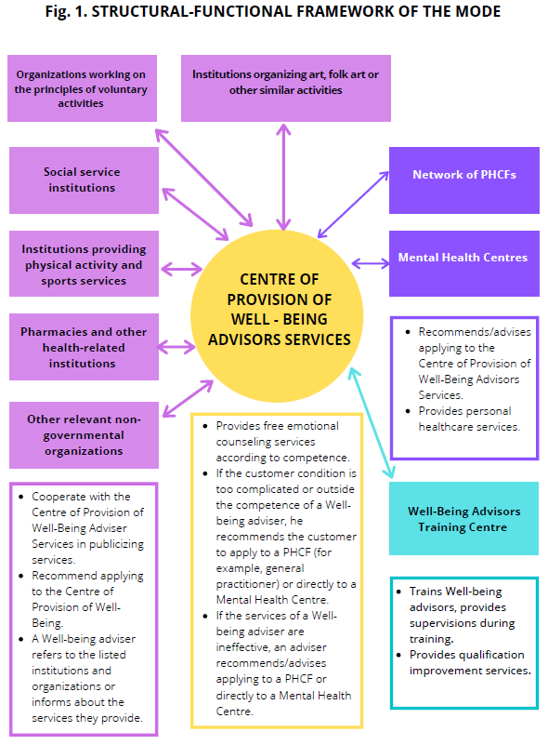
KEY ELEMENTS OF THE PRINCIPLES OF SERVICE PROVISION

          - 1. CENTRE OF PROVISION OF WELL-BEING ADVISERS SERVICES

          - ENSURES:

          - 1.1. ACCESSIBILITY OF THE SERVICES

    - Free services for individuals from and over 18 years of age;
    - Individuals applying for consultations are admitted without any special referral;
    - The centre is located in a place that is convenient for the service recipients and is easily accessible;
    - The centre works at a time convenient for the service recipients, including time after work hours;
    - Possibility of different ways to register for services, including online registration;
    - Proper service planning in the effort to shorten consultation waiting time;
    - Under adverse conditions, consultations can be provided online.

                - 1.2. The services provided are NON-DISCRIMINATORY, CONFIDENTIALITY and SECURITY are maintained.

    - Services are provided to individuals regardless of their gender, age group, views, sexual orientation, race or nationality. Non-discriminatory services for disabled individuals are provided.
    - The provision of the services is based on mutual respect, mutual understanding and agreement.
    - Confidentiality of the service recipient is ensured, for example, personal information has to be encrypted and stored in accordance with personal data protection requirements.
    - It is ensured that the services are provided in a secure environment that meets the needs of the service recipient. Physical premises should be soundproof, consultations must be carefully planned so that individuals would have to wait as short as possible at the door of the room, in the corridor or outdoors.

1.3. QUALITY OF THE SERVICES

    - The services are provided by Well-beingadvisers who have completed special training and who receive regular refresher training (see point 2.1).
    - To select the measures that are most appropriate for an individual applying to the centre and for assessing the condition and dynamics of the service recipient:
      - WHO-5 Well-Being Assessment Survey;
      - Visual Analogue Scales;
      - Standardized health questionnaires PSK9 and GAD7 are completed.
    - The service recipients are properly informed about the nature of the services, their own condition and the possibilities of receiving the service.
    - The change in the condition of the service recipient is monitored during each meeting with a Well-being adviser.
    - The services provided are documented. Approved service documentation and the use of questionnaires for assessing the standard emotional state of the service recipient at defined periodicity during the sessions.
    - Preparation of reports according to the established indicators and their submission to evaluators of the work of Well-being advisers Centres, i.e. to the founders of Well-being advisers Centres or other institutions that finance the services provided by Well-being advisers Centres. Reports for the year are submitted annually until 15 February.
    - Convenient working conditions for Well-being Advisers intended to retain professionals.

    - Developed service provision infrastructure (see points 1.1, 1.2).

- WELL-BEING ADVISERS

An algorithm of Well-being Advisers services is shown in Fig. 2.

  - The following individuals can be Well-being Advisers:
2.1.1. Individuals having acquired at least the Bachelor’s degree in the following study fields (according to the List of Study Fields and Study Fields Groups according to which studies take place in higher education institutions approved by the Order No V-1075 of the Minister of Education and Science of the Republic of Lithuania of 1 December 2016):
      - Field of health sciences: G01 Medicine, G04 Public Health, G06 Rehabilitation, G08 Nursing and Midwifery;
      - Field of social sciences: J04 Social work, J07 Psychology.
    - Professionals having completed training of low-intensity emotional counseling of individuals experiencing psychological and emotional difficulties based on cognitive and behavioural therapy (more broadly – in Section 6) and having a document proving this fact.
  - Key functions of Well-being Advisers:
    - To organise an initial meeting during which, through survey, the mental health needs and level of psychological well-being of the individual applying to the centre and risk factors are assessed, and a service provision plan is drawn up.
    - Mental health needs, level of psichological well-being and risk factors are assessed based on work reports of Centres of provision of well-being advisers services and on analysis of completed questionnaires and scales.
    - To recommend contacting a personal health care facility providing mental health care services when symptoms of mental and behavioural disorders are suspected to have occurred and, in their presence, a Well-being advisers cannot, within the limits of his competence, help an individual, to provide information on which facility provides such services and to explain the procedure for receiving these services.
    - To provide, according to the service plan that has been drawn up at the first meeting, evidence-based low-intensity emotional counseling services (more broadly – in Section 9) individually to individuals encountering emotional difficulties and, during the consultations, periodically assess the emotional state in accordance with the established procedure.
    - To administer own activity, i. e. to fill in a log of services provision which must specify data of the services recipient, in accordance with the principles of ensuring confidentiality, time of arrival, duration of the consultation provided; to write down on a regular basis results of the service recipient's standard emotional state assessment questionnaires.
    - If necessary, to recommend the service recipients to apply to a professional acting or institution operating in a relevant field on the issues that do not fall within the competence of a Well-being advisers.
  - To participate, during the Project, in training for Well-being Advisers (more broadly – Section 6) and in supervisions (more broadly – in Section 7) with an experienced professional.

- WELL-BEING ADVISERS TRAINING CENTRE

  - During the Project “CREATION OF THE MODEL OF WELL-BEING ADVISERS” (LT03-1-SAM-TF-002) (hereinafter – the Project), training of Well-being Advisers is provided by Lithuanian University of Health Sciences. For that purpose, within the framework of the Project, a pilot training program for Well-being Advisers has been prepared, and there is a plan to train 30 Well-being Advisers.
  - During the Project, training will be divided into special 8 learning blocks of 5 days each (320 hours of direct learning in total or 40 hours of direct contact per block), which will consist of theoretical and practical parts. The theoretical part, i.e. theoretical lectures, will account for 40% (128 hours) of the time, and the remaining part of the time, i.e. 60% (192 hours), will be devoted for practical classes.
  - During the Project, supervisions will be an important part of the learning process (see Section 7). Supervisions are divided into individual supervisions and clinical supervisions. During the training, each training participant will be given 70 individual supervisions and 54 group 1-hour clinical supervisions.
  - After the end of the Project, it is planned to train advisers on a regular basis and to carry out the training program, adjusted taking into account the results and observations obtained during the Project, at least once a year when funding is available.

- COOPERATION WITH OTHER INSTITUTIONS AND ORGANIZATIONS

  - The Centre of Provision of Well-Being Adviser Services actively cooperates with personal health care facilities (PHCF), especially with general practitioners, and with mental health centres (MHC):
    - If the condition of the recipient (individual) of Well-being Advisers service is unclear, complicated or help that is right for the service recipient is outside the competence of a well-being advisers, the latter shall actively advise/recommend an individual to contact a PHCF (for example, his general practitioner) or a MHC in which he has a direct right to get help (for example, for consultation with a medical psychiatrist) (more broadly – in Section 9).
    - If, after assessing the change in the condition of the service recipient, a Well-being adviser sees over the course that his efforts are not effective enough, a well-being advisers shall cease providing consultations and shall actively advise/recommend an individual to contact a PHCF (for example, his general practitioner, another professional) or a MHC in which he has a direct right to get help (for example, for consultation with a medical psychiatrist) (see Section 9).
    - A PHCF and a MHC inform their service recipients in good faith about services of Well-being Advisers and recommends that they be contacted by individuals who need / could benefit from such services.
  - The Centre of Provision of Well-Being advisers Services cooperates, on a mutually beneficial basis, with other institutions and organizations, such as social service institutions, pharmacies, psychological assistance institutions, organizations working on the principles of voluntary activities, institutions providing physical activity and sports services, institutions organizing art, folk art or other similar activities, other relevant non-governmental organizations:
    - Institutions exchange between each other information that is relevant and useful for their service recipients;
    - direct their service recipients for specific services if demand for such services arises;
    - initiate and organize joint service publicity campaigns for the public and other parties concerned.

- PRINCIPLES OF IMPROVEMENT OF THE ACTIVITIES OF CENTRES OF PROVISION OF WELL-BEING ADVISERS SERVICES

5.1. Development of innovative, accessible, non-discriminatory services adapted for various groups of society.
5.2. Introduction and development of remote services.
5.3. Implementation and application of electronic administration and evaluation tools.
5.4. Close cooperation with PHCF (general practitioners), MHS or other interested institutions or institutions that are relevant to the service recipients.
5.5. Sharing good practices and problems with Centres providing Well-being advisers services in the same and other municipalities, for example, organization of annual events / meetings / conferences, organization of joint training for Well-being Advisers, etc.

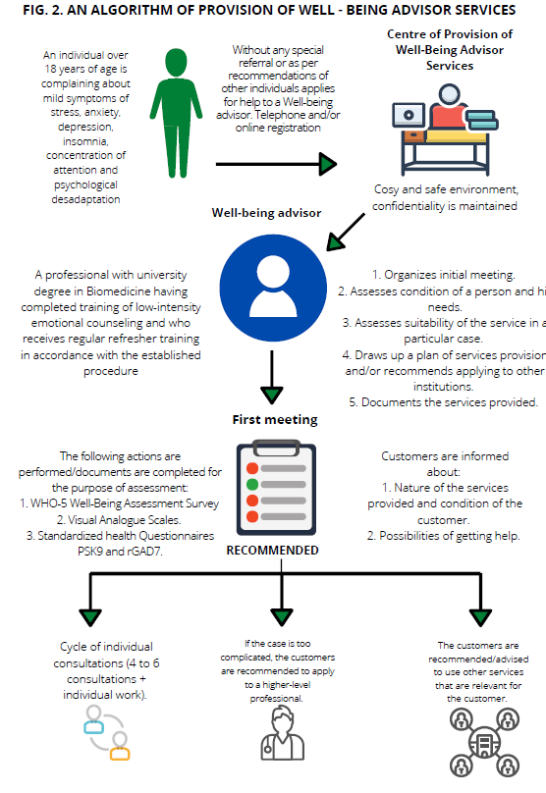

- TRAINING AND QUALIFICATIONS OF WELL-BEING ADVISERS
Training will be divided into special 8 learning blocks of 5 days each (40 hours of direct contact), which will consist of theoretical and practical parts. The theoretical part, i.e. theoretical lectures, will account for 40% (16 hours) of the time, and, during one block, 2 learning days will be devoted for that, and the remaining part of the time, i.e. 60% (24 hours), will be practical classes, and 3 days during one block will be devoted for that. In case of the need for distance learning and if there will be such a possibility, training will take place remotely, using information and electronic communication technologies.
THEORETICAL LECTURES
There will be 2 days of theoretical lectures in one learning block. One training day will consist of 4 lectures, the duration of one of them - 2 hours. A total of 16 days or 128 hours will be devoted for theoretical lectures.
PRACTICAL CLASSES
During 8 learning blocks, besides theoretical lectures, practical classes will also take place. One learning block will consist of 5 learning days of 8 hours each (40 hours), 60% of which (24 hours) will be practical classes, or 3 days during one learning block. A total of 192 hours during the training is devoted for practical classes.

- SUPERVISIONS AND THEIR TYPES
Supervision is the counseling assistance to Well-being Advisers to ensure the quality of the services they provide and security in advising service recipients during training. A supervisor is a specially trained professional who understands the specifics, nature, and objectives of the work of Well-being Advisers, who is deeply familiar with the methods of cognitive and behavioural therapy (CBT) and the specifics of low-intensity services used in the context of tiered treatment.
Supervisors: doctors-psychotherapists or persons with the Master's degree in clinical or health psychology, who have completed special university training in CBT and CBT professionals who have been practicing for more than 3 years.
Supervisions are divided into:
- Individual supervisions;
- Clinical supervisions.

Individual supervisions
Individual supervision (case management), which will take place both during the training and throughout the consultation period during the Project, are designed to discuss individually, together with a Well-being advisers, the progress of the service recipients of the Well-being advisers. Supervisions take place directly or remotely. By advising a Well-being advisers, a supervisor helps to assess the situation and select the best aid measures.
For example, if the condition of a particular service recipient is not improving, it may be necessary to change the counseling strategy, or additional training may be required to improve counseling skills. It is possible that the case is simply too complicated and it is necessary to refer the service recipient to a higher-level professional. It is possible that service recipients do not complete the course because they are not provided enough information which would motivate them to continue receiving advises.

A supervisor also helps identify risks and manage them. Possible risks: suicidal ideation, somatic diseases, development of psychosis, more severe mental disorders have emerged and other problems. Duration of supervision - 1 academic hour. During individual supervisions, other participants in the training course may be given the opportunity to participate as observers.

Clinical supervisions
During clinical supervisions, one supervisor works with a group of program participants - Well-being Advisers (in a group of 7-10 training participants). During clinical supervisions, the main focus is on training of advisers, qualification improvement, development of skills and answers are provided to questions of their concern, in working with all service recipients. A supervisor can advise on the suitability of the services for different service recipients and assess the abilities of the advisers. Supervisions take place remotely or directly. Duration of clinical supervision - 1 academic hour.

- CRITERIA OF SELECTION OF WELL-BEING ADVISERS
- Higher or equivalent education (Bachelor’s degree or higher).
- Professionals who have degree in biomedicine (doctors, including trainee specialist doctors having not completed specialisation training, nurses, public health professionals, healthy lifestyle professionals) and professionals who have degree in social sciences (psychologists, social workers).
- High emotional intelligence, willingness and ability to provide psycho-emotional support to people experiencing psychological problems/difficulties, and to work consistently and improve skills in the field of mental health in the pursuit of the set goal together with the service recipient.
- Work experience working in the field of service recipient consulting would be an important advantage.
- Good communication skills (including by phone): active listening, ensuring feedback, effective cooperation and decision making, sincerity and compassion.
- Objectivity, honesty, courtesy, constructiveness.
- No addiction (including smoking) or they were overcome more than a year ago.
- Tolerance, respect for ethics, preservation of the dignity and confidentiality of the service recipient.
- Ability to independently plan and organize own time and activities, to deal with problems and conflicts, to work effectively in a team.
- Desire to improve, ability to learn, responsibility, dutifulness, timely completion of work.
- Understanding of the provided services of the health care system, especially in the field of mental health.
- Ability to collect, systematize, generalize information and prepare conclusions.
- Ability to use information technologies such as MICROSOFT OFFICE programs, ZOOM, VIBER, WHATSAPP, etc.
- Sufficient knowledge of the Lithuanian language for free communication.
Following the pre-selection of candidates performed by the applicants, the candidates proposed will be evaluated during a standardized individual interview.
9. SERVICES PROVIDED BY WELL-BEING ADVISERS
I. POSSIBLE TYPES OF SERVICE:
1. Evaluation - the beginning of the consultation cycle or the first session.
2. Individual live consultation during the course of consultation cycle or remote consultation using an online communication platform or by telephone.
3. Final consultation that completes the consultation cycle
4. Recommendation to contact a PHCF or a MHC.
II. INDIVIDUAL CONSULTATIONS
A cycle of individual consultations consists of an average of 4-6 direct consultation sessions (minimum 2, maximum 8) in about 8-10 weeks, and homework. If necessary, individual consultation sessions or short interventions can be also provided remotely (online, using special programs adapted for this purpose, by phone).
III. BEGINNING OF A CYCLE OF CONSULTATIONS
During the first consultation, the service recipient's condition is assessed and a consultation plan is drawn up according to a typical model.
During the first meeting:
1.1.1. An initial assessment of the service recipient is performed. Eligibility/compliance of the person for Well-being advisers services is determined during the assessment;
1.1.2. An interview that is oriented towards the service recipient is conducted. It helps to identify the key problems of the service recipient and their level of complexity. A risk assessment is performed (likelihood of suicide, injuries of oneself or of others). The adequacy of the service recipient's perception of his problem is also assessed. Depending on the complexity and peculiarities of the case, the service recipient is informed about the possibilities of receiving the service. In the further provision of the services, techniques of consulting work are selected, for example behavioural promotion, exposure, cognitive restructuring, anxiety management, relaxation techniques, problem solving, insomnia management.
1.1.3. It is recommended that the service provider complete standardized questionnaires:
1.1.3.1. WHO-5 Well-Being Assessment Survey form (planned during the first and last meetings);
1.1.3.2. Visual Analogue Scales (during each meeting);
1.1.3.3. PSK-9 and GAD-7 during each meeting).
1.1.4. In between of consultations, the service recipient is given independent work assignments.
IV. IMPLEMENTATION OF THE CONSULTATION CYCLE
Counseling techniques that are based on cognitive and behavioural therapy (CBT) are applied during the consultations. The duration of the consultation is 60 minutes. 45 minutes of this time are spent working with the service recipient, and 15 minutes are spent to complete the documentation. Changes in the condition of the service recipient are monitored during each meeting. It is not only a means of monitoring as to whether the condition of the service recipient is improving, or maybe is deteriorating, but also a tool for the professional which helps to pay attention to important details. For example, the service recipient, who shows symptoms related to anxiety disorder, may have less obsessions. It seems to indicate that his condition is improving. However, if the service recipient has less obsessions because they are much more avoided, from this the professional may conclude that the condition has not yet improved, and perhaps it has even deteriorated, and it is likely that the techniques applied should be adapted according to the needs of the service recipient.
V. COMPLETION OF THE CONSULTATION CYCLE
Services of Well-being Advisers are completed:
• when a person has been provided with a set number (maximum of 8) of consultations, which have led to improvement of the person's state of health, significant improvement in symptoms and a positive change in rating scales can be seen;
• when fewer than planned consultations have been provided but the service recipient wishes to stop consultations because his condition has improved significantly.
During the counselling cycle, the service recipient develops tools for self-reflection and emotional strengthening, which help strengthen emotional health after the end of the cycle. Of course, the service recipient is reminded that he can always turn to a Well-being advisers or mental health professional again if he feels the need to do so.
VI. RECOMMENDATION FOR THE SERVICE RECIPIENT TO SEEK HIGHER-LEVEL SERVICES
A higher level – personal health care facility. If the symptoms of the service recipient show mild disorder, he may be offered well-being consultations at the spot. But if the case is too complicated and is beyond the competence of the professional, the service recipient is recommended to apply to a personal health care facility (PHCF/MHC), i.e. to contact a clinical/health psychologist, psychotherapist, psychiatrist or general practitioner.
OTHER RECOMMENDATIONS
Well-being Advisers may refer service-recipients also to use services of other facilities and organizations (see Fig. 1).

